**Cafeteria Management System (Cashless Canteen)**

|  |
| --- |
| User interface design document |
| Version 1.0  19 November, 2013 |
| Autumn 2013-14  DA-IICT, Gandhinagar |

**Overview**

UI Design Document describes the interface design choices made for the Cafeteria Management Project and also explains its front end functionalities.

**Target Audience**

Software Development Team

Client

**Document Revision History**

|  |  |  |  |  |
| --- | --- | --- | --- | --- |
| **Version** | **Author(s)** | **Description** | **Reviewer(s)** | **Date** |
| 1.0 | Prateek Sanadhya | UI design document v1.0 |  | 19 November, 2013 |
|  |  |  |  |  |
|  |  |  |  |  |

Contents

1. Introduction 4

1.1 purpose………………………………………………………………………………………………..4

1.2 scope…………………………………………………………………………………………………4

2. UI design overview 4

2.1 Requirements 4

2.2 UI design approach and tasks 5

3. Screenshots of developed website 6

**1. INTRODUCTION**

## Purpose

The purpose of this document is to provide a description of the user interface design made for Cafeteria Management project.

Its main purpose is to –

* To explain the design choices made for the project.
* To explain navigation system of the interface.
* To explain front end functionalities.

## Scope

This document shall be used to systematically note and explain user interface design of the Cafeteria Management System. It also documents certain front-end features of the project.

# 2. UI Design Overview

## Requirements

The outer quality of a project depends on its user interface design. The first impression that a project makes is based on its front end. A client, at the first sight can see only its front end, if it is not good, the back end also suffers.

The User interface is divided into four sections:

* Customer
* Cafe owner
* Admin
* CMC(cafeteria management committee)

The specific UI requirements for the Cafeteria Management System are:

* A more dynamic and interactive portal with improved information architecture.
* Systematic and easy to use navigation system.
* A separate design layout for customer page, admin page, cmc page and cafe owner’s page.
* User profiles which display all relevant information about the users.
* UI for cafe owners should be made as simple as possible so that they directly use it without wasting their time in understanding it.
* Large icons and buttons will be used so that they are easily visible.

**2.2 UI DESIGN APPROACH AND TASKS**

Our approach towards implementing the UI design requirements was centered around firstly understanding basic structure and functionalities of a canteen. We examined how things work in the food courts of a mall. Once we established certain familiarity with them we started tweaking the codes to experiment with the platform and learn by actually doing.

In discussion with our clients, requirement analysis team and our team leader we developed proper understanding of the requirements – layouts of various pages, navigation system, front-end features, etc. We have tried to make the interface design a balanced mixture of the *sober* and the *extravagant*.

We have created different web layouts according to the users. Our index page(first page) is the login page which is common for all users. As the user logs in, the next page to be displayed will depend on the type of user such as admin, customer, cmc or a cafe owner.

Admin’s home page is provided with a navigation bar and some buttons in its header that allows him to navigate easily.

Customer’s home page is provided with a header containing buttons and various tiles(blocks) on the page helps the customer to navigate through food courts.

Cafe owner’s home page is made as simple as possible. A header with buttons is provided and a separate block is designed that contains a textbox to enter the amount, two buttons to add and subtract amount and a label that displays the total amount.

We have not used any animation or an image slider so that the website loads faster and does not delay. Only light weight images are used.

# 3. SCREENSHOTS OF THE DEVELOPED WEBSITE

**Login**

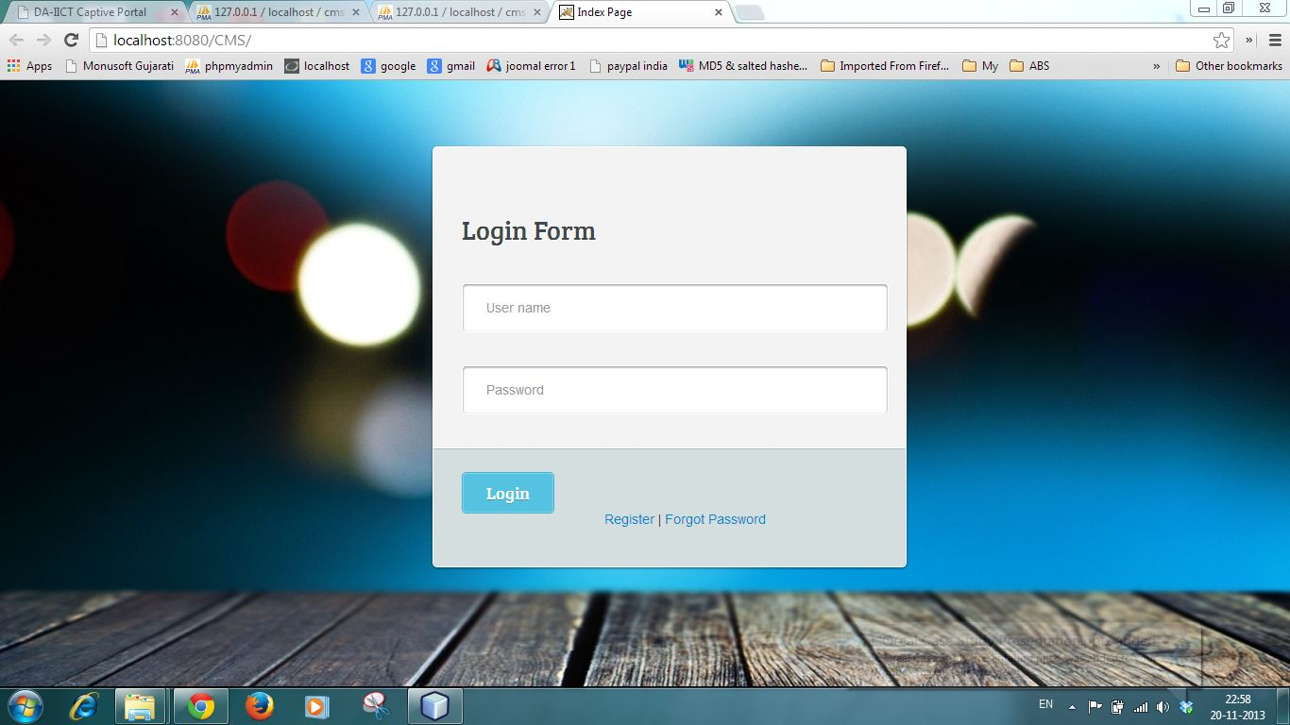

**Logout**

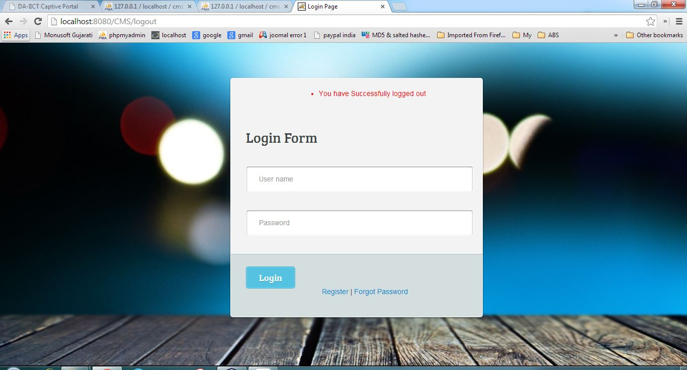

**Admin Home**

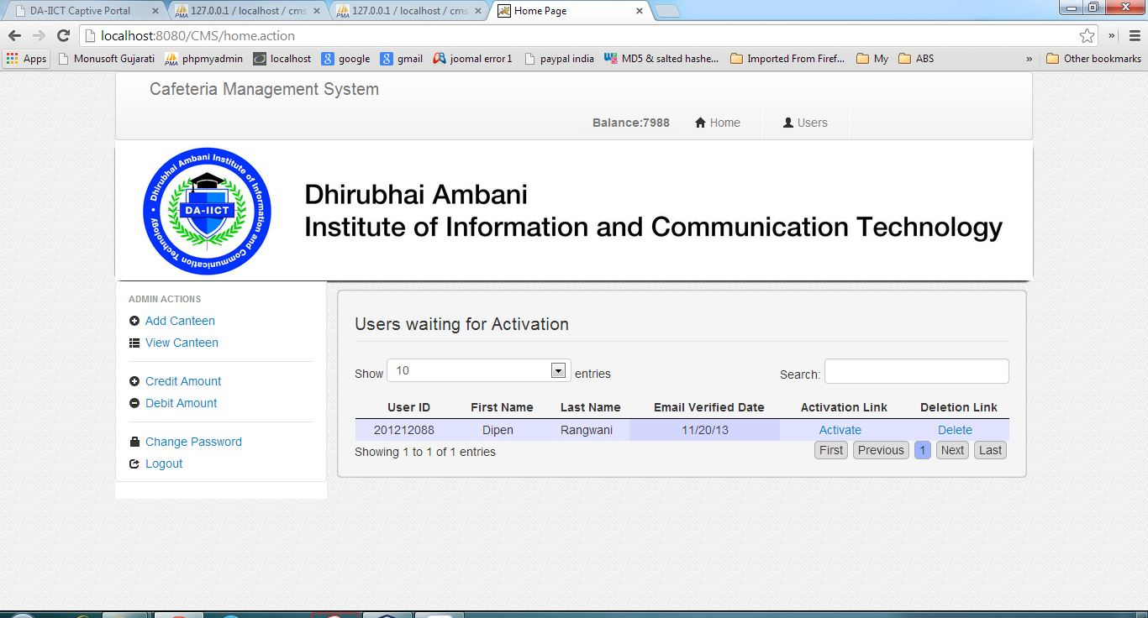

**Admin Users**

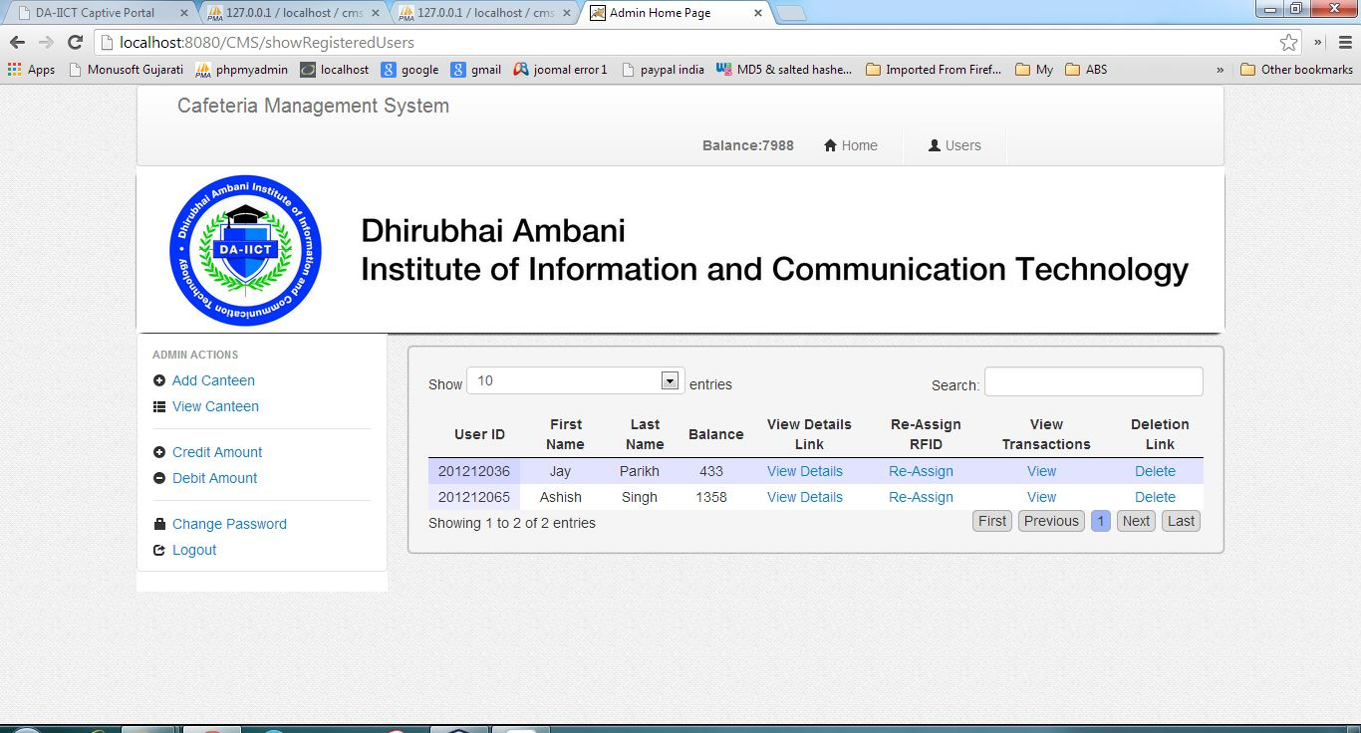

**Admin Add Canteen**

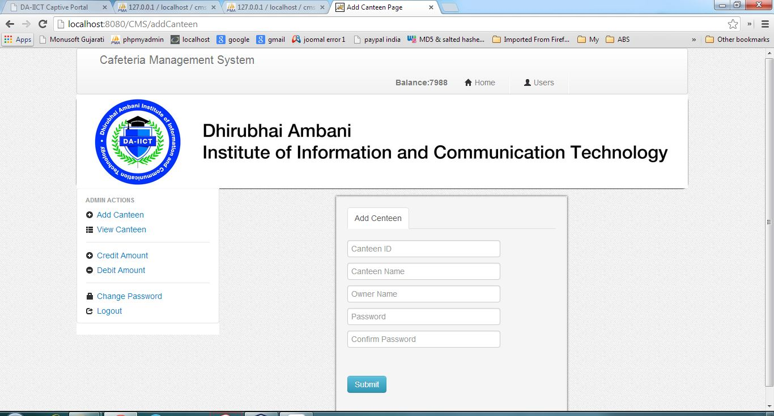

**Admin View Canteen**

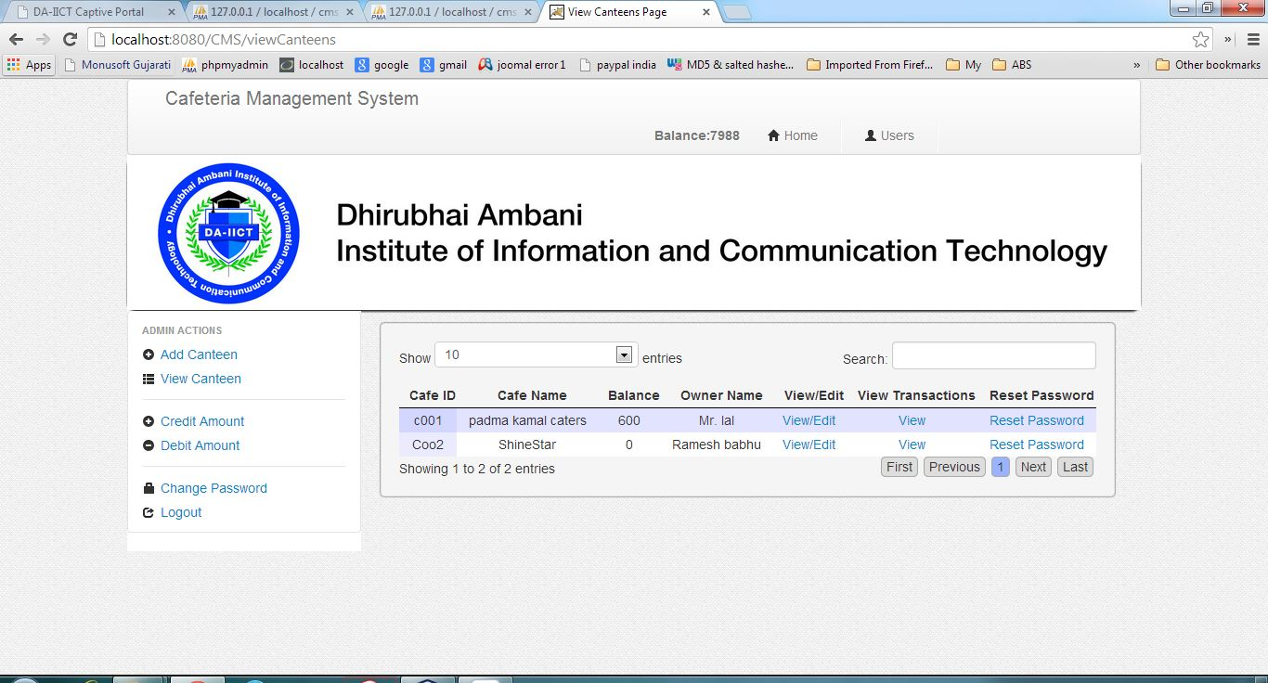

**Admin Credit**

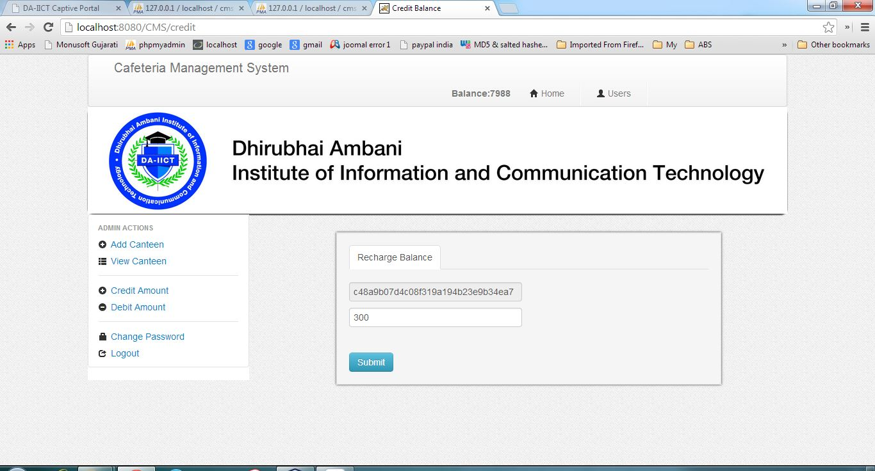

**Admin Debit**

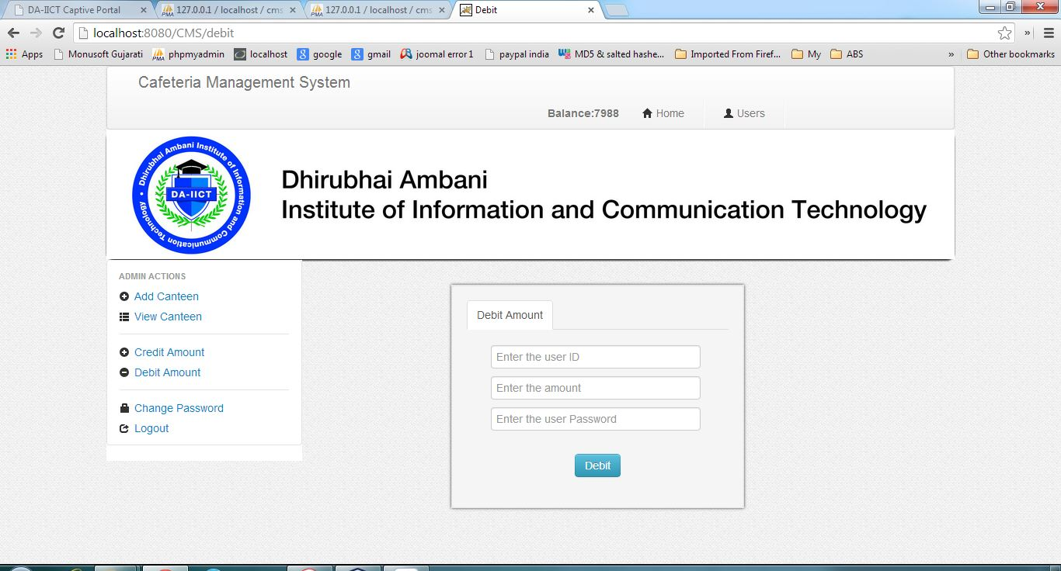

**Admin Change Password**

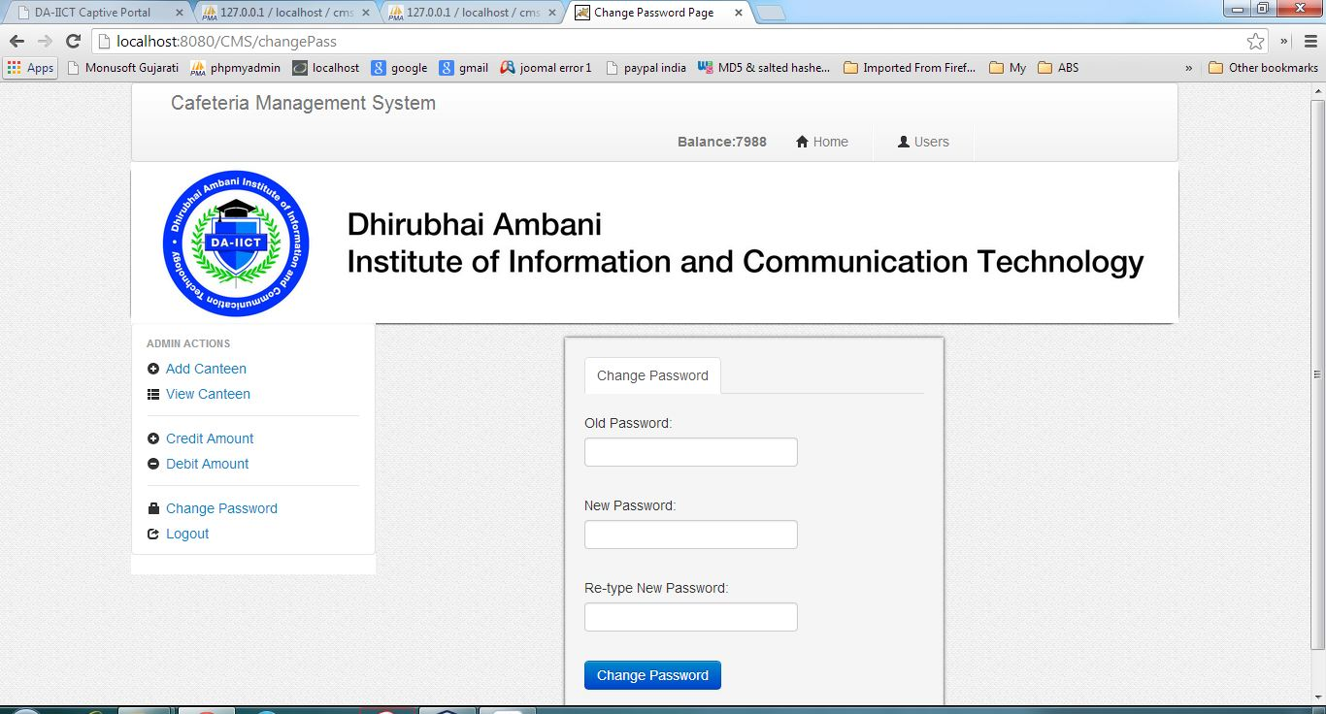

**Customer Home**

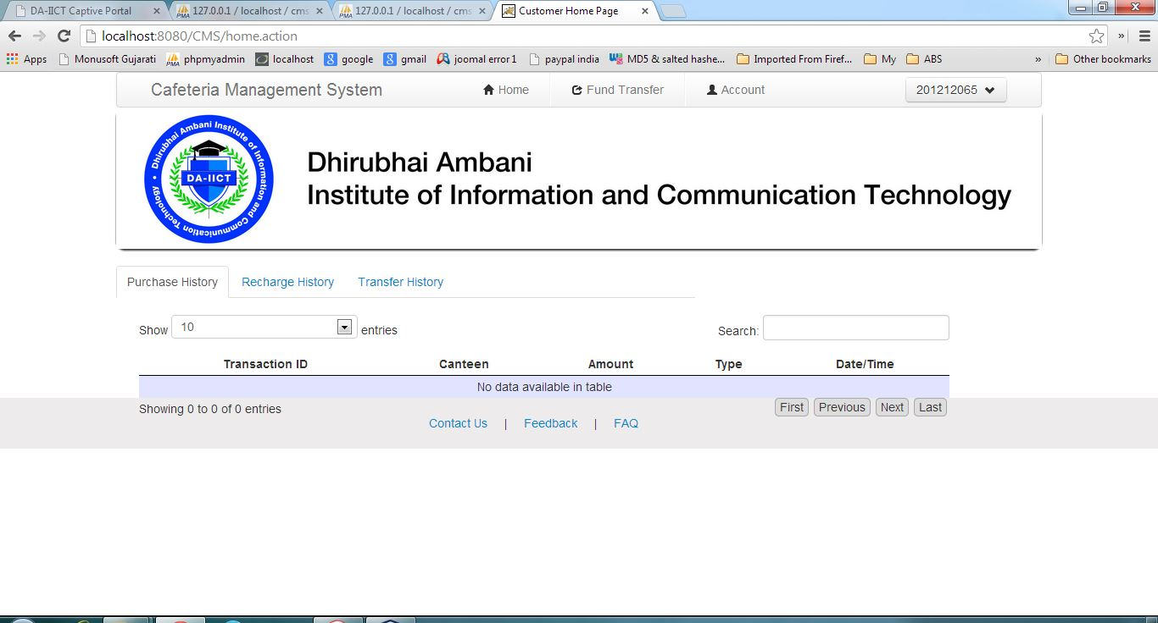

**Customer Recharge History**

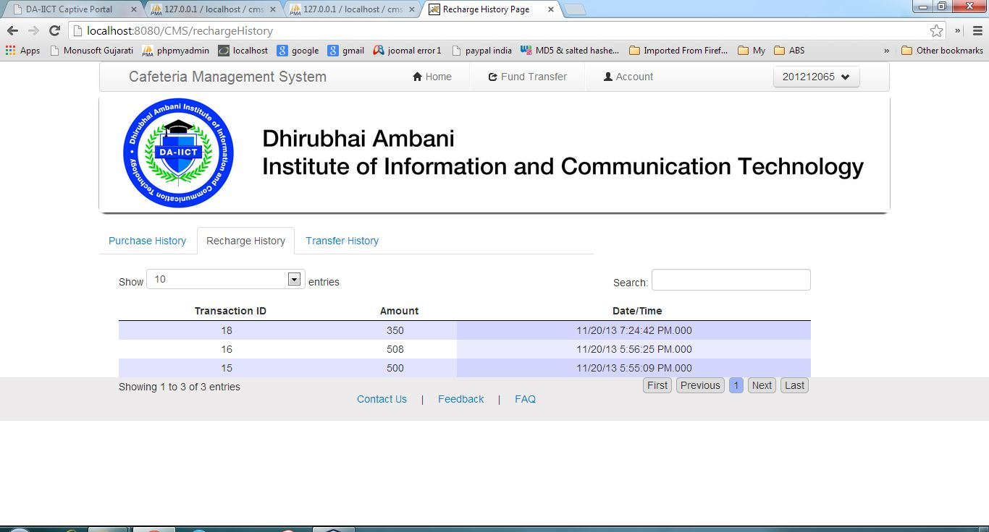

**Customer Transfer History**

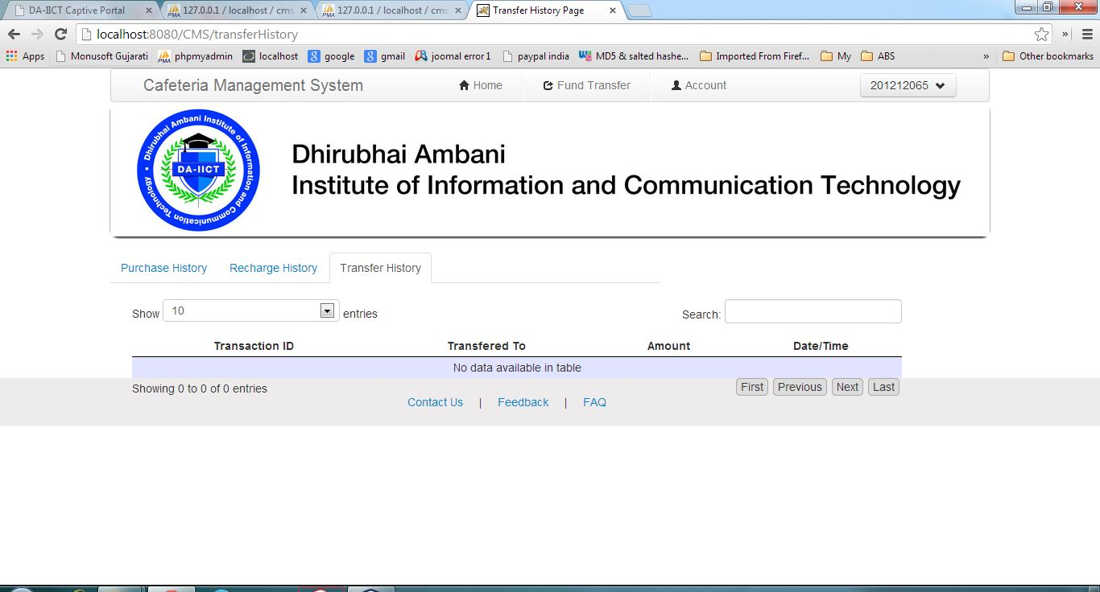

**Customer Fund Transfer**



**Customer Account**

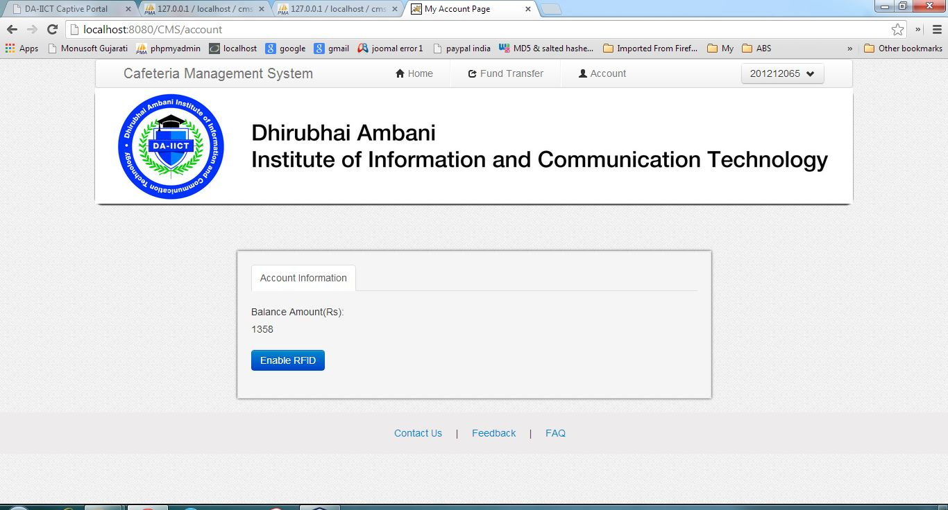

**Customer Update Profile**

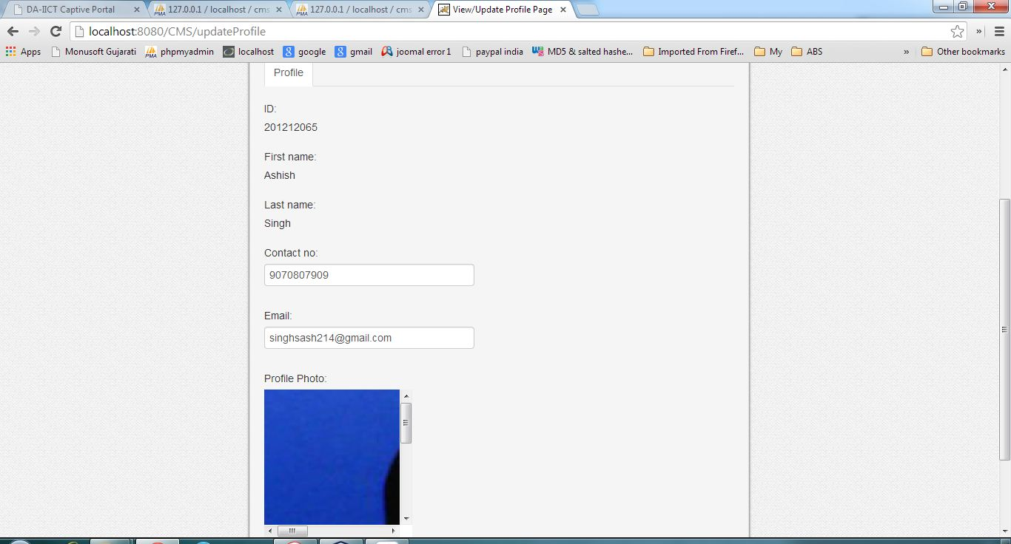

**Canteen Home**

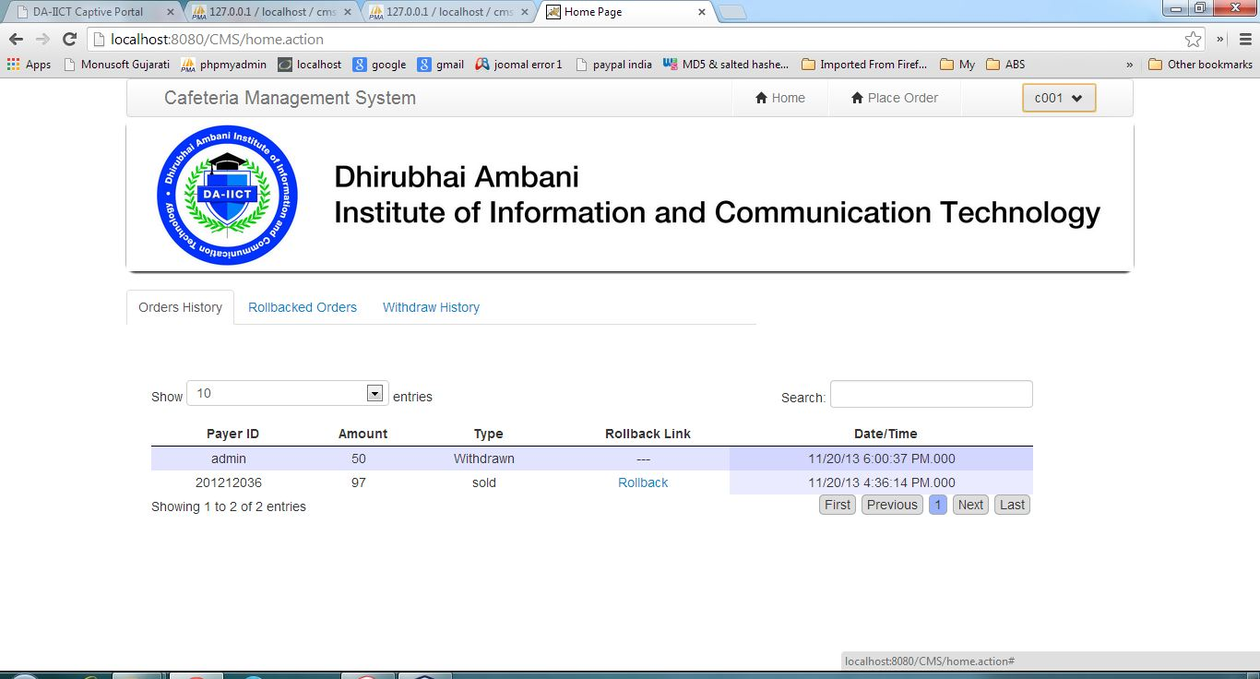

**Canteen Rollback Order**

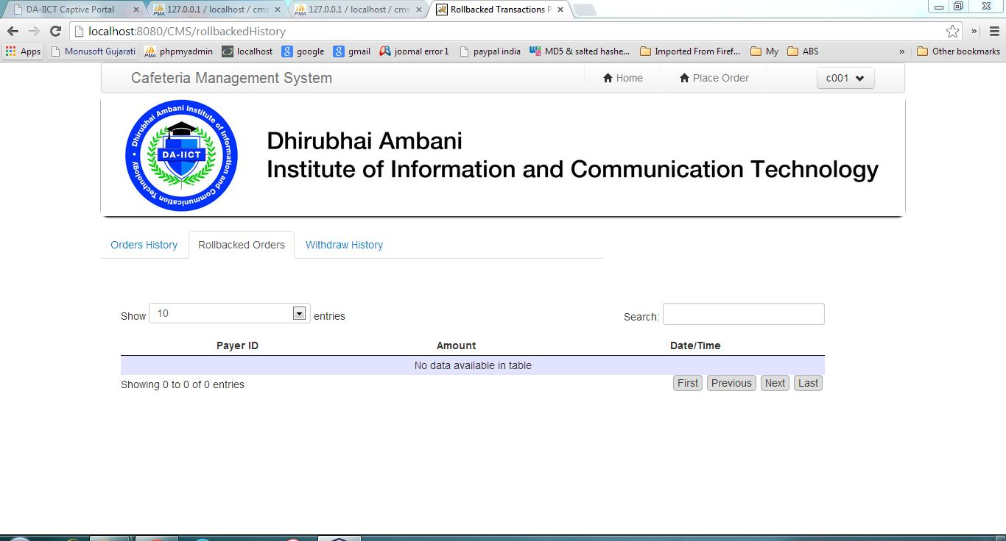

**Canteen Withdraw History**

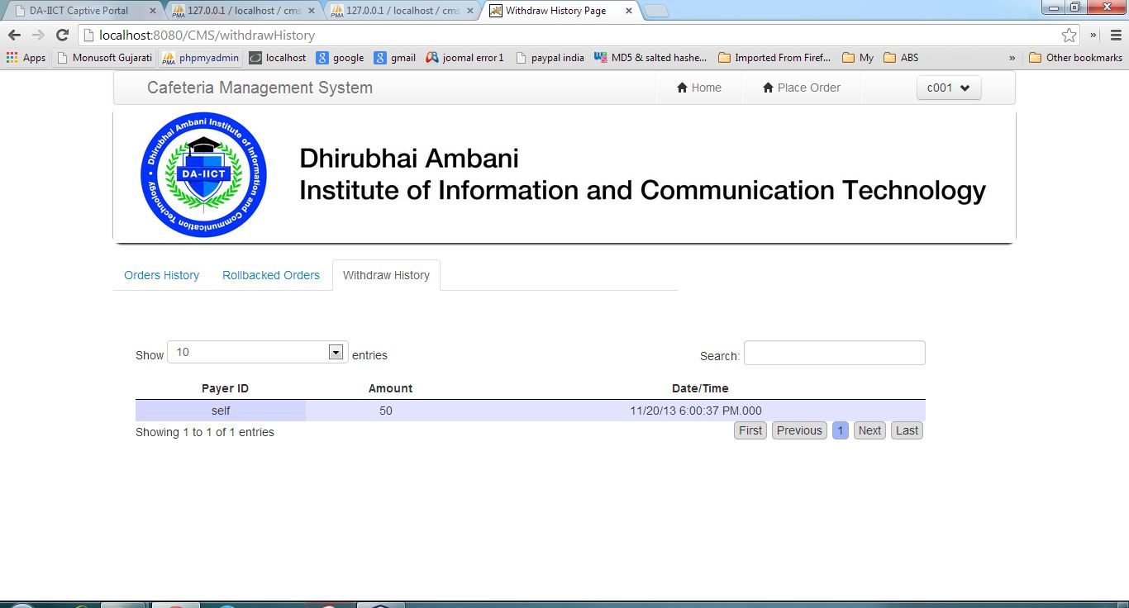

**Canteen Place an Order**

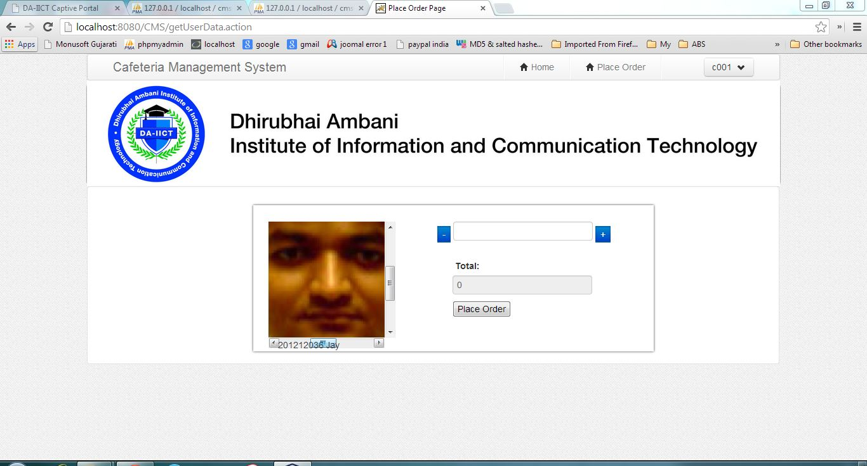

**CMC Home**

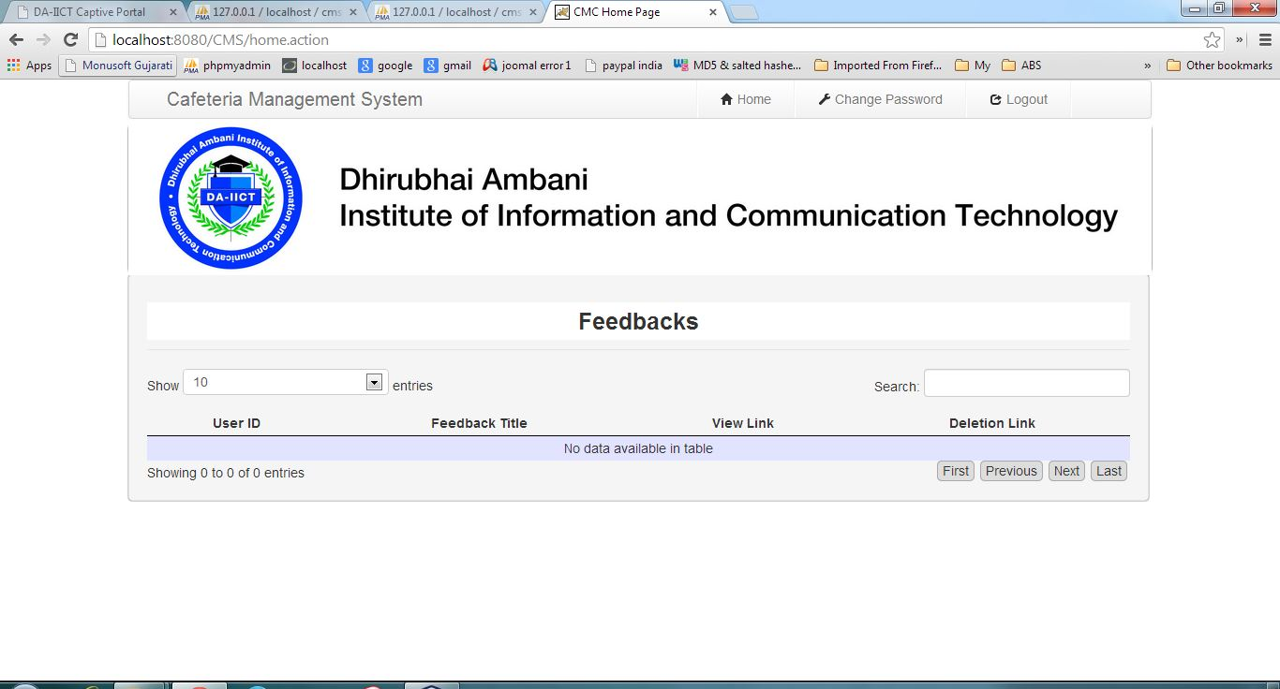

**Registration**

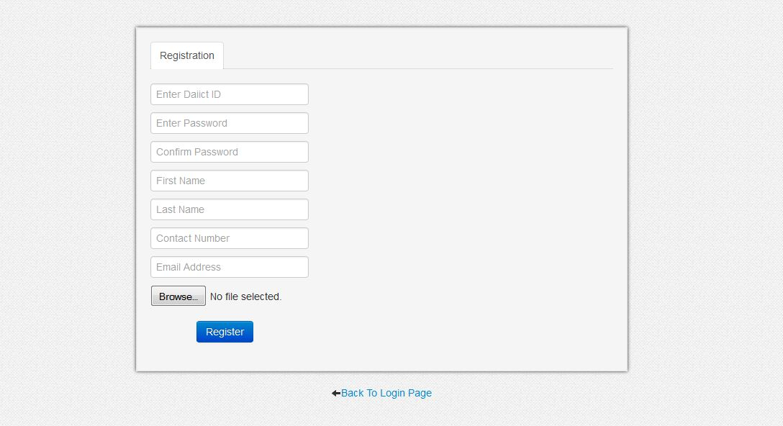

**Forgot Password**

